Healthcare Data Integration and Analysis - Submission
This template helps you capture and share screenshots of your code and results for each task.

Instructions
- Insert value or screenshots showing the relevant output and code, as mentioned in the tasks of the project.
- If one screenshot cannot clearly show both code and output, use two screenshots placed one after the other.
- Ensure all screenshots are readable.
- You can share the screenshots in any of the following formats: .png, .jpg, .jpeg, .jfif, .webp, .bmp, .tiff, .tif

Task 1: Import the data sets from text files into spreadsheet format
Task | Activity name | Screenshot of both the code and output
1a | Screenshot of Pharmacy_Claims.xlsx | <Paste the screenshot here>  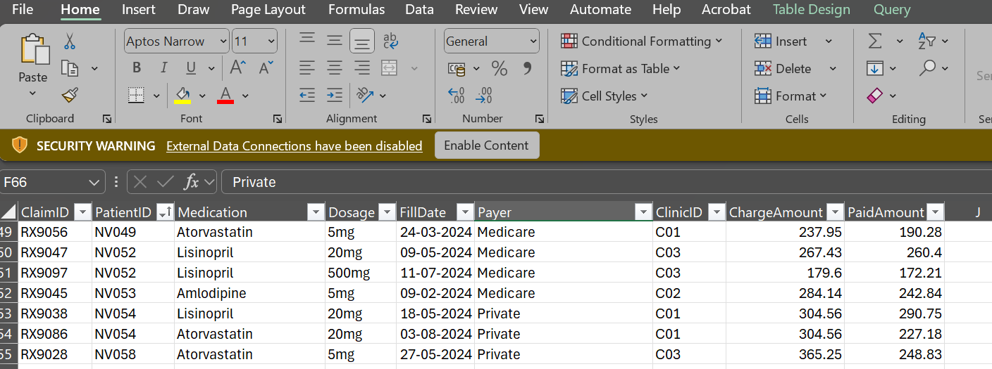
1b | Screenshot of Lab_Results.xlsx | <Paste the screenshot here>  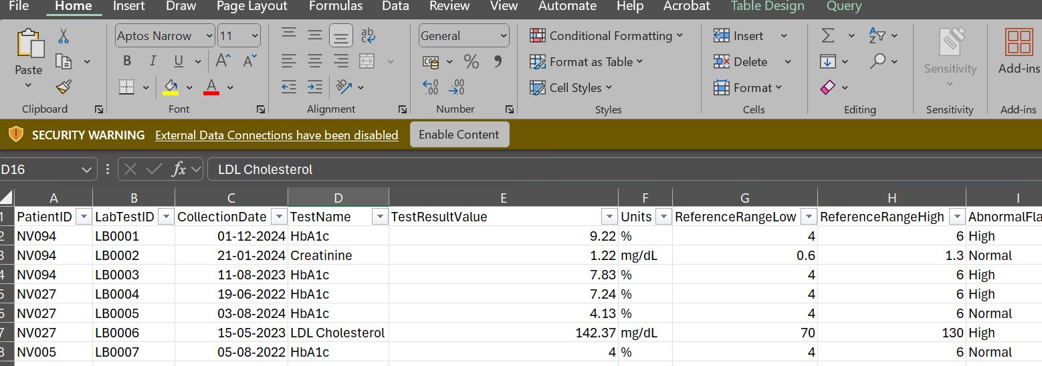

Task 2: Analyze the data sets using Excel
2.1a | Considering the Pharmacy_Claims data set, how many paid amounts exceed $250? | <Write the answer here>  21
2.1b | Considering the Pharmacy_Claims data set, which payer has paid the highest amount? | <Write the answer here>  Medicaid
2.1c | Considering the Pharmacy_Claims data set, what is the total amount paid by the payer identified in part 2.1b. | <Write the answer here>  6180.81
2.2a | Based on the Lab_Results data set, what is the top result within the LDL Cholesterol test. | 187.1
2.2b | Based on the Lab_Results data set, what is the average value for the LDL Cholesterol test? | 134.6
2,2c | Based on the Lab_Results data set, how many patients have high LDL Cholesterol (> 160 mg/dL)?? | 12

Task 3: Identify and fix the issues in a data set using Python
Activity number | Activity name | Screenshot
3.1a | Write the Python code to identify the number of missing values. | <Insert the code or the screenshot of the code here>  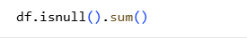
3.1b | Write the Python code to identify the number of duplicate values. | <Insert the code or the screenshot of the code here>
3.1c | Write the Python code to identify inconsistent categorical entries in the Gender column. | <Insert the code or the screenshot of the code here>  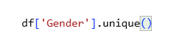
3.1d | Write the Python code to identify inconsistent date formats in the AdmissionDate column. | <Insert the code or the screenshot of the code here>
3.2a | Write the Python code to handle missing values appropriately. | 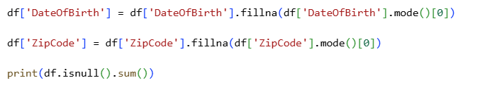
3.2b | Write the Python code to remove exact duplicate rows. | 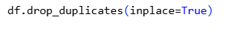
3.2c | Write the Python code to standardize gender values. | <Insert the code or the screenshot of the code here>  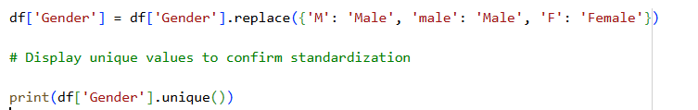
3.2d | Write the Python code to standardize date values. | <Insert the code or the screenshot of the code here>

Task 4: Analyze the data sets using SQL
Activity number | Activity name | Screenshot
4a | Write an SQL query to list all patients born before 1980. | <Insert the code or screenshot of the code here>  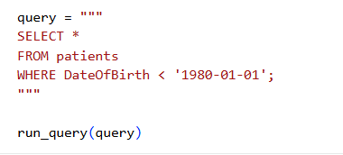
4b | Write an SQL query to list all female patients with Type 2 Diabetes. | <Insert the code or the screenshot of the code here>  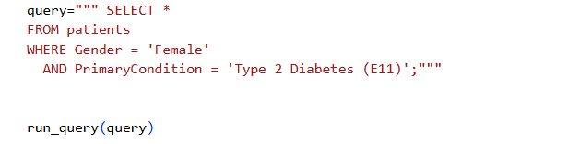
4c | Write an SQL query to display all lab tests performed. List each patient (PatientID, Gender, and DateOfBirth from patients) with their lab test name and result value (TestName and TestResultValue from lab_results). | <Insert the code or the screenshot of the code here>  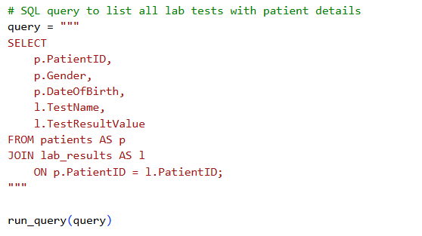
4d | Write an SQL query to display all distinct patients with their payer(s). List each patient (PatientID, Gender, DateofBirth from patients) with their payer(s) from the pharmacy_claims data set. | <Insert the code or the screenshot of the code here>  